

Dr. Jason, Morton inc.
2019-12-13
Dr. Morton
86999 Robert Club, South Wendyshire, IL 93746
Phone: 5603790754
Fax: 7131455444

Re: Sabrina, Johnson
PHN: 3627382911
Birthdate: 13-Nov-1980
Address: 31042 Chelsea Haven, Lake Kimberlyport, AS 40448
Patient number: 9438864551

To Whom It May Concern:

This is a medical letter to state the above patient is pregnant with expected delivery date of 16-Mar-2025. Hoping this information is satisfactory for your requirements.

Thank you.

Sincerely,
Dr. Jason, Morton
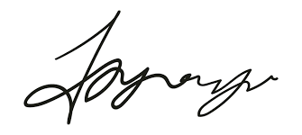
FRCS© NCMP
Clinical Assistant Professor, UBC
Department of Obstetrics and Gynecology SMH

